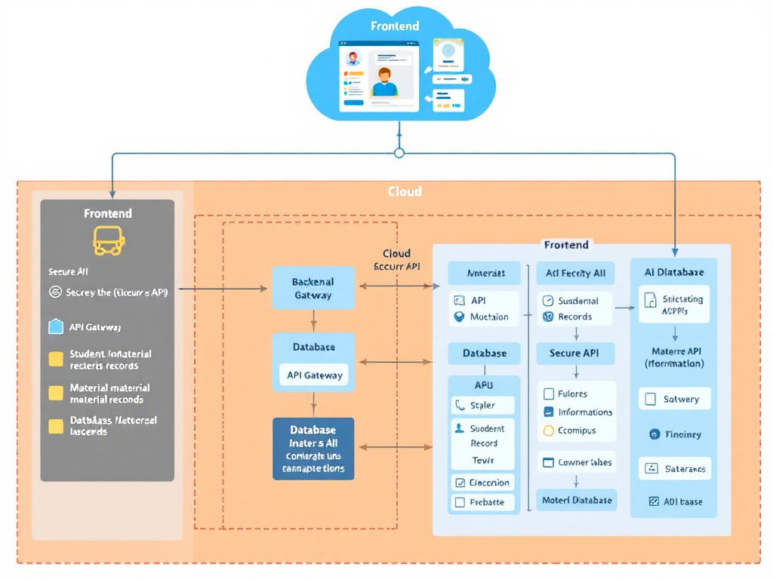

Fig 5.1.1: System architecture

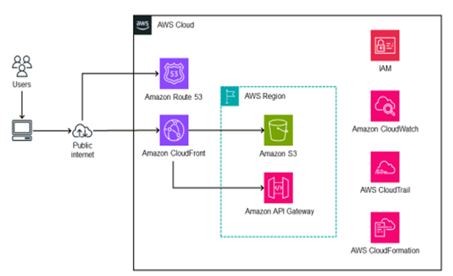

Fig 5.1.2: Aws cloud architecture

